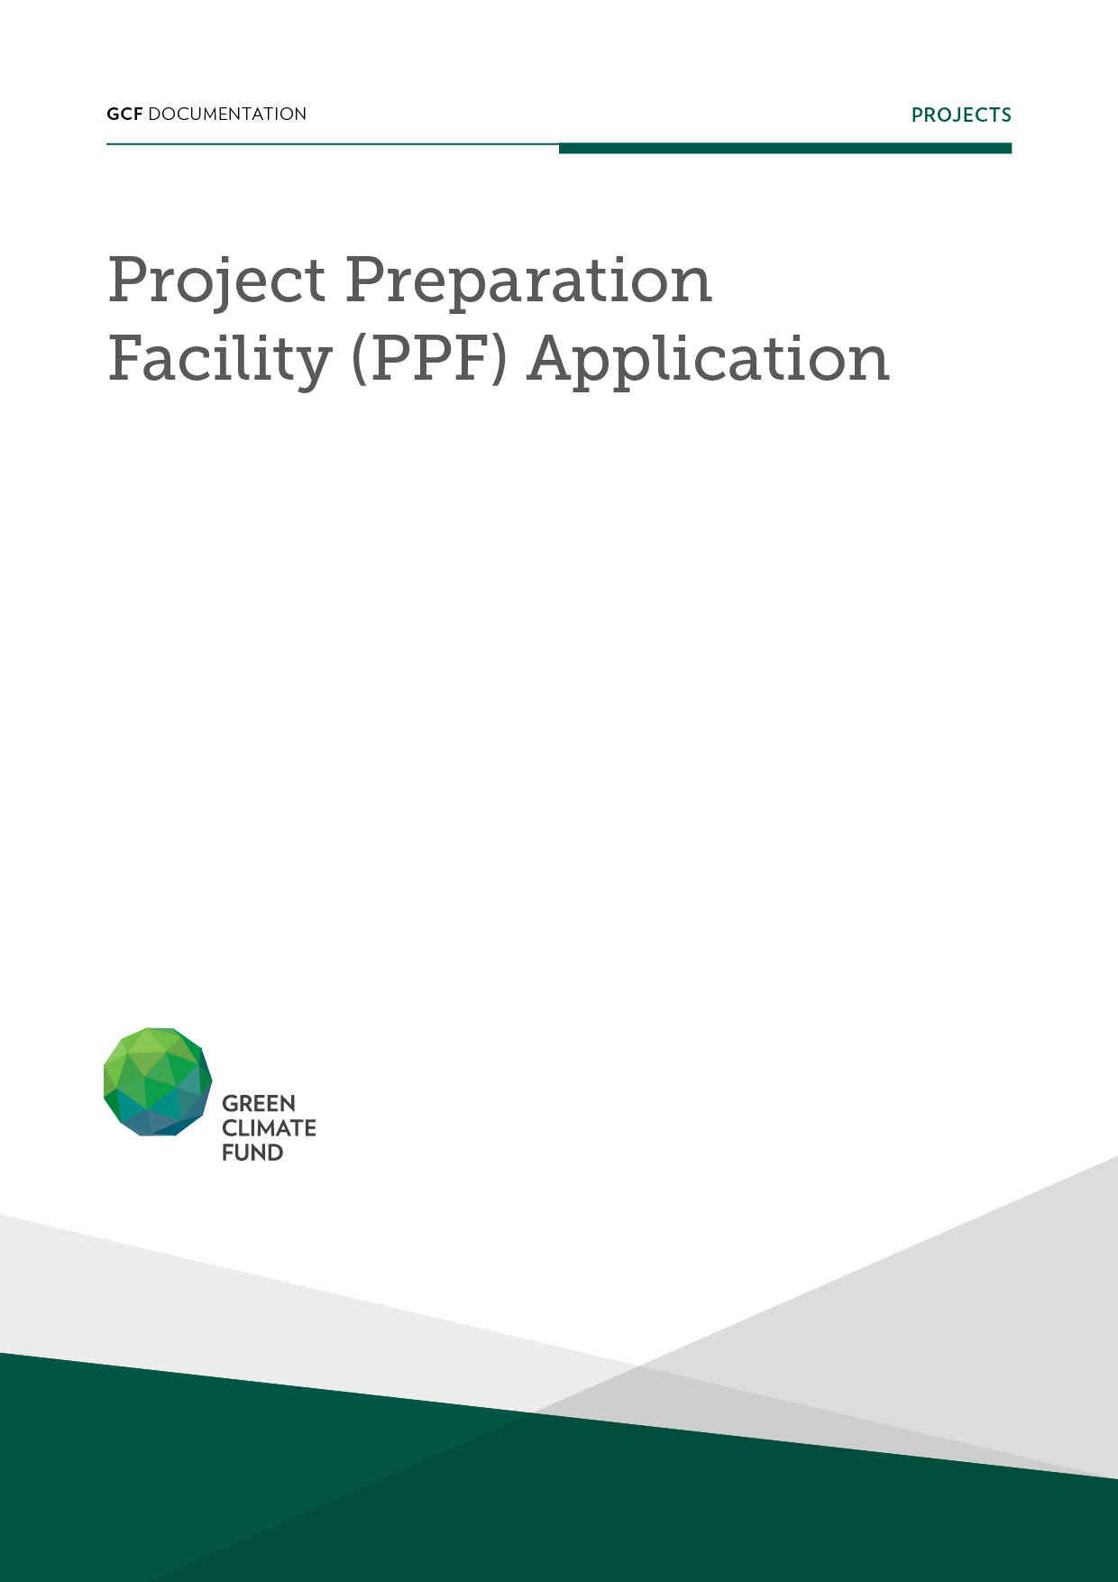

Effective 1 July 2026, all PPF application requests are required to be submitted through the GCF Partner Portal (GPP) online application system. This template is provided for guidance and reference purposes only.

Concept note title
Accredited Entity
Country(ies)
First submission | Day Month Year
Current submission | Day Month Year (version#: XX)

Please submit the completed PPF application and the PPF no-objection letter to ppf@gcfund.org. Refer to the PPF Guidelines for further information on completing the PPF application.
A. Executive Summary
A.1 | Accredited Entity (AE)
A.2 | Title of concept note submitted with PPF application | Please indicate full project/programme title.
A.3 | Countries / NOL Date
  Country | Date of NOL received
A.4 | PPF support requested | Funding/Service
A.5 | Support from Readiness | Has the AE accessed Readiness support for preparing the CN or PPF application? | ​​☐​ Yes [indicate relevant modality]  ​​☐​ No
A.6 | Cost of PPF activities | Amount requested from GCF  Only applicable to PPF Funding | ​​☐​ Grant | USD ​amount​
A.6 | Cost of PPF activities | Amount requested from GCF  Only applicable to PPF Funding | ☐ Repayable grant | USD ​amount​
A.6 | Cost of PPF activities | Amount requested from GCF  Only applicable to PPF Funding | ☐ Equity | USD ​amount​
A.6 | Cost of PPF activities |  | In-Cash | In-Kind
A.6 | Cost of PPF activities | Co-financing from AE | USD ​amount​ | USD ​amount​
A.6 | Cost of PPF activities | Co-financing from other sources | USD ​amount​ | USD ​amount​
A.6 | Cost of PPF activities | Total co-financing amount | USD ​amount​ | USD ​amount​
A.6 | Cost of PPF activities | Total project preparation cost | USD ​amount​
A.7 | Implementation period | ​​Expected number of months to implement the PPF activities​
A.8 | Summary of PPF request
​​Please provide a brief description of the project preparation activities.​
(max. 1000 words)

B. Justification for Project Preparation Support
Please explain the AE’s needs for project preparation funding from GCF, including any cash or in kind resources from the AE and co-financing for funding proposal development.
(max. 1000 words)

C. Implementation Arrangement, Risks & Mitigants
Please describe implementation arrangements for project preparation activities, including a diagram and narrative description of the roles and responsibilities of the entities involved (NDA, AE, executing entities, procured parties, sub-grantees, as applicable), legal relationships between entities, flow of funds (not applicable to PPF Service), steering committees, and AE staff and consultant contribution arrangements. If seeking PPF Funding with procurement of international or local consultants by the AE, please provide the AE’s procurement plan. Also identify any risks and mitigants to implementation.
(max. 2500 words)

GCF requires the inclusion of these four mandatory risks in the risk section. Additional risks, as applicable to the PPF request, should also be added in this section.
Risk 1 | Money Laundering
Risk Origin | Project Related
Risk Area | Integrity
Risk Sub-area | Money Laundering (ML) & Terrorist Financing (TF)
Description | Please type here...
Consequences | Please type here...
Inherent Risk | Likelihood | Impact | Severity
Inherent Risk | 2 - Possible | 3 - Medium | 6 - Medium
Mitigation Measure(s) | Please type here...
Residual Risk | Likelihood | Impact | Severity
Residual Risk | 1 - Unlikely | 2 - Low | 2 - Low
Comments | Please type here...
Risk 2 | SANCTIONS
Risk Origin | Project Related
Risk Area | Integrity
Risk Sub-area | Sanctions
Description | Please type here...
Consequences | Please type here...
Inherent Risk | Likelihood | Impact | Severity
Inherent Risk | 1 – Unlikely, 2-Possible, 3-Likely, 4-Almost Certain, 5-Certain | 1 - None (Close to); 2 - Low (Some); 3 - Medium (Significant); 4 - High (Serious); 5 - Catastrophic (Operations compromised). | Will auto-calculate when entered in system
Mitigation Measure(s) | Please type here...
Residual Risk | Likelihood | Impact | Severity
Residual Risk | 1 – Unlikely, 2-Possible, 3-Likely, 4-Almost Certain, 5-Certain | 1 - None (Close to); 2 - Low (Some); 3 - Medium (Significant); 4 - High (Serious); 5 - Catastrophic (Operations compromised). | Will auto-calculate when entered in system
Comments | Please type here....
Risk 3 | FRAUD / BRIBERY & CORRUPTION / COLLUSION
Risk Origin | Project Related
Risk Area | Integrity
Risk Sub-area | Fraud / Bribery & Corruption / Collusion and any other prohibited practice
Description | Please type here...
Consequences | Please type here...
Inherent Risk | Likelihood | Impact | Severity
Inherent Risk | 1 – Unlikely, 2-Possible, 3-Likely, 4-Almost Certain, 5-Certain | 1 - None (Close to); 2 - Low (Some); 3 - Medium (Significant); 4 - High (Serious); 5 - Catastrophic (Operations compromised). | Will auto-calculate when entered in system
Mitigation Measure(s) | Please type here...
Residual Risk | Likelihood | Impact | Severity
Residual Risk | 1 – Unlikely, 2-Possible, 3-Likely, 4-Almost Certain, 5-Certain | 1 - None (Close to); 2 - Low (Some); 3 - Medium (Significant); 4 - High (Serious); 5 - Catastrophic (Operations compromised). | Will auto-calculate when entered in system
Comments | Please type here...
Risk 4 | CONFLICT OF INTEREST
Risk Origin | Project Related
Risk Area | Integrity
Risk Sub-area | Conflict of interest
Description | Please type here...
Consequences | Please type here...
Inherent Risk | Likelihood | Impact | Severity
Inherent Risk | 1 – Unlikely, 2-Possible, 3-Likely, 4-Almost Certain, 5-Certain | 1 - None (Close to); 2 - Low (Some); 3 - Medium (Significant); 4 - High (Serious); 5 - Catastrophic (Operations compromised). | Will auto-calculate when entered in system
Mitigation Measure(s) | Please type here...
Residual Risk | Likelihood | Impact | Severity
Residual Risk | 1 – Unlikely, 2-Possible, 3-Likely, 4-Almost Certain, 5-Certain | 1 - None (Close to); 2 - Low (Some); 3 - Medium (Significant); 4 - High (Serious); 5 - Catastrophic (Operations compromised). | Will auto-calculate when entered in system
Comments | Please type here...

D. Description of project preparation activities
Summary of activities and Outputs  Please select PPF activity and add rows as needed. Submit detailed terms of reference outlining scope of work and deliverables as a separate annex. Please also complete the "PPF Application and Deliverables Completeness Self-Check" and include it with your application. |  | Implementation Period  Please shade the expected duration, up to 24 months. Indicate completion target with an 'X'.
 |  | 1 | 2 | 3 | 4 | 5 | 6 | 7 | 8 | 9 | 10 | 11 | 12 | 13 | 14 | 15 | 16 | 17 | 18 | 19 | 20 | 21 | 22 | 23 | 24
Activity 0 | Inception phase activities  Please provide brief description for each sub-activity. |  |  |  | X
Activity 1 | Pre-feasibility and feasibility studies, and project design  Please provide brief description for each sub-activity. |  |  |  |  |  |  |  |  |  |  |  |  |  |  |  |  |  |  |  |  |  |  |  | X
Activity 2 | Environmental and social studies, including Indigenous Peoples studies  Please provide brief description for each sub-activity. |  |  |  |  |  |  |  |  |  |  |  |  |  |  |  |  |  |  |  |  |  |  |  | X
Activity 3 | Gender studies  Please provide brief description for each sub-activity. |  |  |  |  |  |  |  |  |  |  |  |  |  |  |  |  |  |  |  |  |  |  |  | X
Activity 4 | Development of stakeholder engagement plans  Please provide brief description for each sub-activity. |  |  |  |  |  |  |  |  |  |  |  |  |  |  |  |  |  |  |  |  |  |  |  | X
Activity 5 | Risk assessments  Please provide brief description for each sub-activity. |  |  |  |  |  |  |  |  |  |  |  |  |  |  |  |  |  |  |  |  |  |  |  | X
Activity 6 | Assessment of climate impact potential for mitigation and adaptation activities  Please provide brief description for each sub-activity. |  |  |  |  |  |  |  |  |  |  |  |  |  |  |  |  |  |  |  |  |  |  |  | X
Activity 7 | Identification of programme- and project-level indicators  Please provide brief description for each sub-activity. |  |  |  |  |  |  |  |  |  |  |  |  |  |  |  |  |  |  |  |  |  |  |  | X
Activity 8 | Pre-contract services, including the revision of tender documents  Please provide brief description for each sub-activity. |  |  |  |  |  |  |  |  |  |  |  |  |  |  |  |  |  |  |  |  |  |  |  | X
Activity 9 | Advisory services and/or other services to financially structure a proposed activity  Please provide brief description for each sub-activity. |  |  |  |  |  |  |  |  |  |  |  |  |  |  |  |  |  |  |  |  |  |  |  | X
Activity 10 | Other project preparation activities, where necessary, and with sufficient justification  Please provide brief description for each sub-activity. |  |  |  |  |  |  |  |  |  |  |  |  |  |  |  |  |  |  |  |  |  |  |  | X
Submission of funding proposal
Additional period for review by GCF Secretariat and Independent Technical Advisory Panel

E. Terms of Reference for Project Preparation Activities
Please provide detailed terms of reference for each project preparation activity, including expected scope of work, planned deliverables, no. of days per deliverable, technical qualifications of consultants of consultancy firms expected to undertake specific activities. A separate word file may be provided.
Please type here or upload the TORs for the PPF application to this section.

F. Budget Summary (applicable to PPF Funding applications only)
Outputs or Activities level budget summary  Please fill out the detailed budget template and submit it along with this application. Add rows as needed. | USD from GCF | USD from  AE / co-finance | Total cost, USD
Activity 1
Activity 2
Activity 3
Activity 4
Activity 5
Activity 6
Activity 7
Activity 8
Activity 9
Activity 10
Total activity-level costs
Additional costs and fees
Contingency (up to 5% of total activity-level costs)
Project Management Cost (up to 7.5% of total cost + contingency)
Sub-total of project preparation costs
Accredited Entity Fee (up to 8.5% of sub-total)
Total GCF PPF funding requested (sub-total + AE fee)

G. Budget Summary (applicable to PPF Funding applications only)
G.1 For AEs without framework readiness and preparatory support grant agreement with GCF
For PPF Funding requests of 12 months or less | 1st tranche | 90% of total grant, equating to USD ​amount​, to be disbursed upon or after effectiveness of the Grant Agreement and fulfilment of conditions in Grant Agreement Standard Conditions.
For PPF Funding requests of 12 months or less | Final tranche | 10% of total grant, equating to USD ​amount​, will be disbursed upon submission of a completion report and final audit report.
For PPF Funding requests of 12 months or more | 1st tranche | 50% of total grant, equating to USD ​amount​, will be disbursed upon or after effectiveness of the Grant Agreement and fulfilment of the conditions specified in Grant Agreement and Standard Conditions.
For PPF Funding requests of 12 months or more | 2nd tranche | 40% of total grant, equating to USD ​amount​, will be disbursed (provided that at least 70% of the 1st Tranche has been committed) upon submission of an interim progress report and Certified Financial Report from CFO/Head of Finance or designated official and upon fulfilment of conditions in Grant Agreement and Standard Conditions.
For PPF Funding requests of 12 months or more | Final tranche | 10% of total grant, equating to USD ​amount​, will be disbursed upon submission of completion report and final audit report.
G.2 For AEs with framework readiness and preparatory support grant agreement with GCF
The following paragraph to be completed by the AE:
Disbursements will be made in accordance to [Clause xx] “Disbursement of Grants” and [Clause xx] “Use of Grant Proceeds by the Delivery Partner” of the Framework Readiness and Preparatory Support Grant Agreement entered into between GCF and [AE’s name] on [date].
H. Reporting Obligations & Acknowledgements by AE
H.1 | The AE will submit a Funding Proposal to the GCF that is supported by the PPF resources within 2 years of approval of this application, as per GCF Board Decision B.37/22. | ☐ Agree
H.2 | All outputs as approved in the PPF application together with a draft Funding Proposal should be provided no later than 24 months from approval of this PPF application. If PPF grant duration is over 12 months, an Interim Progress Report, and for all grants, a Completion Report, and Certified Financial Reports will be submitted by the AE. Templates can be found on the GCF PPF website. | ☐ Agree
H.3 | If requesting project preparation support via PPF Funding, the AE will be responsible for [and accountable to the GCF under terms of the Grant Agreement to be entered into between GCF and the AE in case of direct grants, or between United Nations Office of Project Services (UNOPS) and the AE in case of grants administered by UNOPS] the overall design, development, management, implementation and supervision of activities financed through the PPF. The AE will be responsible for determining that any sub-grantee(s) have the ability to successfully perform the activities under its overall guidance, management or supervision, according to the terms and conditions of the agreement between the GCF and the AE. | ☐ Agree
H.4 | If requesting project preparation support via PPF Service, the AE will be responsible for managing the independent consultancy firm selected to provide PPF Services; providing instructions to the independent consultancy firm selected to provide PPF Services; and the quality control of the final products of the independent consulting firm. The AE shall provide to the GCF written confirmation that the deliverables by the PPF Services firm are satisfactory and meet the requirements of the AE within thirty [30] days from the date of completion of services by the consultancy firm. The GCF shall have no liability for the performance or quality of the services provided by the independent consultancy firm. To the maximum extent permitted by law, the AE agrees to release the GCF, and its employees, agents and representatives from any and all liability related to damage, loss, cost, expense incurred or injury suffered by the AE or any other party as a result of the project preparation services. | ☐ Agree

